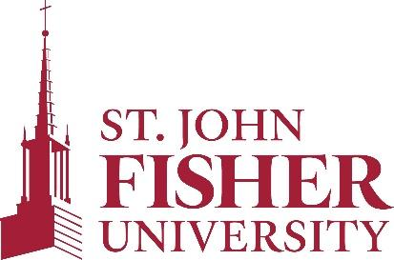
Office of Sponsored Programs and Foundation Relations
PROCESS MAP FOR THE APPROVAL OF RESEARCH PROTOCOLS
FOR GRANT-FUNDED HUMAN SUBJECTS RESEARCH
Established August 2021
Next review: Fall 2023

Pre-Award Stage (proposal stage)
If the grant project appears to include human subjects research, the OSPFR will ask the PI/PD to discuss their project with a member of the IRB committee informally to identify any red flags. A formal IRB application does not need to be submitted at this time.

Post-Proposal Submission Stage
If the grant project includes human subjects research, the OSPFR will encourage the PI/PD to start preparing their IRB application after their grant proposal has been submitted.

Award Negotiation Stage (onset of award)
If a grant involving human subjects research is recommended for an award by the funding agency, the PI/PD will submit a formal application to the IRB committee. The PI/PD must specify in their application that the proposed research will be grant-funded.
The IRB Committee will send their approval or rejection letter to both the PI/PD and the OSPFR.
The OSPFR will forward the IRB approval number to the funding agency. If the IRB does not approve the research protocol, the OSPFR will inform the funding agency and likely the award may not be issued.

Post-Award Stage
The PI/PD is required to ensure that their IRB approval remains active throughout the course of their human subjects research. If their research protocol has changed, they will need to inform the IRB. The Grant Coordinator for Sponsored Programs will remind the PI/PD of this requirement during quarterly check-in meetings throughout the award period.
If the IRB approval is renewed, the IRB Committee will forward the new approval letter to both the PI/PD and the OSPFR.

