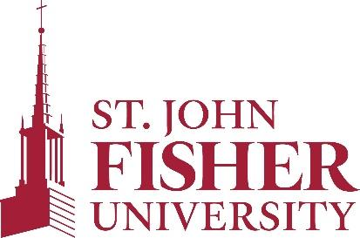

Office of Sponsored Programs and Foundation Relations

Procedures for the Disposition of Federally Funded Equipment

Established: November 2020; Reviewed: September 2021

Next review: Fall 2023

Purpose of these Procedures
To determine when and how pieces of equipment purchased with federal funds may be disposed when no longer needed and ensure responsible stewardship of assets.

Relevant Sections of the Uniform Guidance (UG)
Under section §200.313, “equipment must be used by the non-Federal entity in the program or project for which it was acquired as long as needed, whether or not the project or program continues to be supported by the Federal award, and the non-Federal entity must not encumber the property without prior approval of the Federal awarding agency.”

“Items of equipment with a current per unit fair market value of $5,000 or less may be retained, sold or otherwise disposed of with no further obligation to the Federal awarding agency.”

Steps for Disposing Federally Sponsored Equipment with a Fair Market Value greater than $5,000
- It is the responsibility of the Principal Investigator (PI) or Project Director (PD) to notify the Office of Sponsored Programs and Foundation Relations if a federally funded piece of equipment is no longer needed or needs to be replaced or if the equipment is lost, damaged, destroyed, or consumed. Failure to report the change in status for a piece of equipment may result in University liability to the government.

- The OSPFR will review the Notice of Award and/or consult with agency contacts to determine title to the federally funded equipment.

- The OSPFR will contact the federal awarding agency and/or the General Services Administration to obtain appropriate disposition instructions if a piece of equipment is no longer needed or other instructions if there has been a change in status for the equipment.

- The OSPFR will inform the Director of Procurement of the appropriate disposition steps that need to be taken.

Note the following:
- Records for real property and equipment acquired with Federal funds must be retained for three years after final disposition.
- Records of all federally funded equipment valued over $5,000 must be updated every two years, with the PI/PD completing an Equipment Inventory Form (https://www.sjfc.edu/services/sponsored-programs/forms/) and submitting it to the OSPFR.

