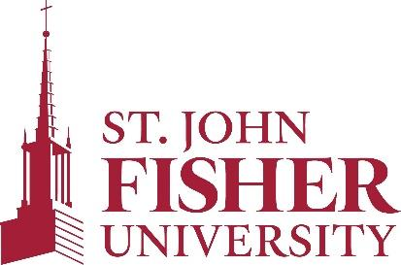

Office of Sponsored Programs and Foundation Relations

PROCEDURES FOR MONITORING GRANT PROGRESS

Created April 2021; Last reviewed: August 2021
Next review: Fall 2023

PURPOSE
The purpose of these procedures is to set guidelines for the Grant Coordinator when performing check-in meetings with the PI/PD and monitor grant progress.

BACKGROUND
The Grant Coordinator (GC) for Sponsored Programs schedules regular meetings with PI/PDs implementing one or more grants. The GC schedules monthly meetings or as requested by the PI/PD (individuals with more experience implementing grant projects may not need monthly meetings). The GC documents the meetings using the PI/PD Grant Progress Checklist.

TOPICS TO REVIEW WITH PI/PD DURING MEETINGS
Status of grant project | - Are you meeting the milestones of the grant project?  - Have you been able to complete objectives?
Challenges | - Have you encountered any problems/challenges?  - What are the possible solutions to solve those challenges?
Personnel | - Have there been any changes to personnel implementing the grant project?
Budget/Spending | - How is the spending going?  - Are there remaining funds in any budget lines that need to be spent or carried over into the next grant year?  - If your grant includes student stipends or scholarships, have you reconciled your numbers with Student Financial Services?
Upcoming deadlines | Grant Coordinator reviews upcoming reporting deadlines/instructions for submission with PI/PD. Grant Coordinator will provide feedback on report before submission.
Subrecipient monitoring (if applicable) | - Is the subrecipient completing deliverables (e.g., achieved project milestones, submitted progress reports)?  - Has the subrecipient submitted invoices?
Certifications | - Did you complete CITI effort reporting training?  - If your students are engaged in federally funded research, did they complete CITI RCR training?  - Is your FCOI certification up-to-date?

Quarterly check-in meetings
On a quarterly basis (based on the College’s fiscal year), the Senior Staff Accountant is invited to join the meeting with the GC and the PI/PD to review grant expenditures and balances, as well as discuss personnel activity reports. During the check-in, the Grant Coordinator will remind the PI/PD to ensure that their IRB approval remains valid, if they are conducting human subjects research.

Grant anniversary meeting
On the grant anniversary, the GC will meet with the PI/PD to discuss the following:
- Financial conflict of interest requirements
- Responsible Conduct of Research requirements
- Identification of foreign influences
- Equipment inventory

120 days prior to the end of the award
The GC and the Senior Staff Accountant will schedule a meeting with the PI/PD 120 days prior to end of the award to discuss close-out procedures. Please see the close-out procedures document for further details.

Final Report to Assistant Provost
Following any meeting with the PI/PD, the GC provides a summary of the meeting to the Assistant Provost. They will develop a plan of action if one is required. They will also inform the Senior Staff Accountant if there are any budgetary issues.

