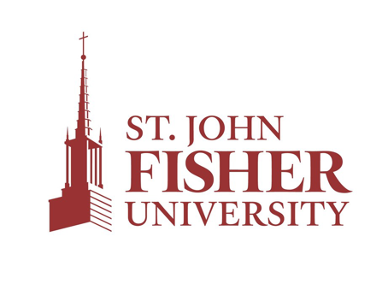

FOR IMMEDIATE RELEASE:

<NAME> Native Named to
St. John Fisher University Dean’s List
PITTSFORD, N.Y., (DATE)—(Name), (son/daughter/child) of (parent’s name), has been named to the (term) (year) Dean’s List at St. John Fisher University in Rochester, New York. (Last name) is a (first-year/sophomore/ junior/ senior) and a (subject) major.
To be eligible for the Dean’s List at Fisher a student must have attained at least a 3.5 grade-point average for the semester.
For more information about St. John Fisher University, visit www.sjf.edu.

###
About St. John Fisher University
St. John Fisher University is a comprehensive liberal arts institution that provides a transformative education to approximately 3,800 undergraduate, master’s, and doctoral students each year. Across its five Schools, Fisher offers nearly 40 majors in the humanities, social sciences, natural sciences, business, education, and nursing; 11 pre-professional programs; and master’s and doctoral programs in business, nursing, education, and pharmacy. Located just beyond Rochester, New York, the University’s 160-acre residential campus boasts a robust living and learning community and through online offerings, attracts students from more than 30 states. An independent institution today, the University was founded by the Congregation of St. Basil in 1948. As Fisher moves forward into the future, it stays true to its Catholic heritage and honors the Basilians by embracing their motto, “Teach Me Goodness, Discipline, and Knowledge.”

